**OSPF & EIGRP Redistribution**

Juntao Zhong

ccnp (cisco certified network professional)

june. 2019

NEWPORT HIGH SCHOOL, WA

## Purpose

The purpose of this lab is to connect OSPF network with EIGRP network, so that routers in two networks can see the other routing protocol in their routing table. Also, by manipulating some parameters in these automated routing protocol, we want to manually set a prefer EIGRP (or OSPF) route when both protocols are viable.

## Backgroud:

Though running a single routing protocol throughout a company’s private network is the most desirable, we might have to configure multi-protocol routing in company mergers, multi-venter networks and/or other conditions. Different routing protocols have their distinct way of calculating the best route, each calculation method has its own advantage.

However, when different a routing protocol competes its routes against the routes from another routing protocols, it runs into an “apple to orange” comparison—the parameters are different, and they are not comparable.

**Enhanced Interior Gateway routing Protocol (EIGRP)** uses bandwidth, delay, reliability load, and MTU (maximum transmission unit) to calculate a composite metric (five parameters known as K1, K2…K5).

* Bandwidth – the slowest bandwidth between the source and destination.
* Delay – the cumulative delay alone the path. For delay value, you divide the time in micro-second by 10. For example, if you want the delay to be 900 μs, input the K2 delay value as 90.
* Reliability – the worst reliability between the source and destination.
* Load – the worst load on a link between source and destination.
* MTU – not actually used in determining routes.

(Default K1, K3 = 1; Default K2, K4, K5 = 0)

Also, Cisco proprietary EIGRP is an enhanced version of RIPv1 because it enables flexible implementation of varied length subnet. And EIGRP can do unequal load balancing while OSPF can’t not; thus, EIGRP is more efficient in distributing traffic within a network.

On the other hand, **Open Shortest Path First (OSPF)** is open standard. It uses only bandwidth to calculate cost. 100 Mbps (reference bandwidth) is divided by the actual bandwidth between routers to calculate cost (for example, if 10 Mbps is the actual bandwidth, cost will be 100/10 Mbps = 10; any result lower than 1 is consider cost=1).

Thus, manual redistribution commands with defined parameters are required for the integration of OSPF and EIGRP networks.

## Lab summary

First, I set up EIGRP network between R1, R2, and R3 as usual. Then, I set up multi-area OSPF between R2, R3, and R4. After testing the connectivity within each routing protocol, I issued redistribution commands so that:

1. The OSPF distributing into EIGRP. The parameter must be: Bandwidth = 245, Delay = 900 microsecond, Load, bandwidth and MTU no requirement.
2. EIGRP need to be distributed into OSPF as **classful** networks.
3. EIGRP Exterior (distributed from OSPF) routes need to have priority over OSPF route. Thus, the Administrative distance of EIGRP Exterior route need to be set to 105, which is lower than OSPF’s 110. (routes with lowest Administrative Distance **(AD)** will be incorporated into the routing table and used as actual route)

## Lab Diagram

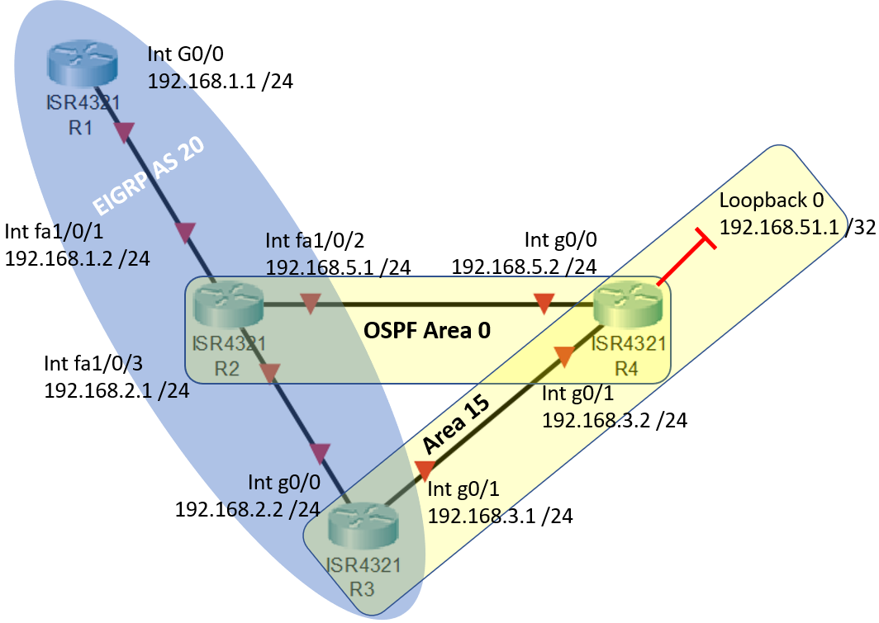

## Lab commands

**redistribute eigrp 20 metric 1 subnets** => Redistribution command in OSPF, the key word **“subnets”** defines the distribution of **classful** network.

**redistribute ospf 1 metric 245 90 245 1 1500** => I set the worst bandwidth = 245, delay = 90 x 10 = 900 microsecond, reliability 245, load 1, and MTU 1500

**distance eigrp 90 105** => do this command in EIGRP configuration. The syntax of command is **distance eigrp [internal EIGRP AD] [external EIGRP AD]**. After this command, AD of internal EIGRP stay as the default EIGRP AD, which is 90; but the external EIGRP is changed from default 170 to now 105. The new 105 AD enables External EIGRP route to outcompete OSPF, which has an AD of 110.

## configuration of both servers and routers

### R1 configuration:

**Router(config)# hostname R1**

interface GigabitEthernet0/0

ip address 192.168.1.1 255.255.255.0

no shutdown

router eigrp 20

network 192.168.1.0

### R2 configuration:

**Switch(config)# hostname Switchrouter2**

ip routing

interface FastEthernet1/0/1

no switchport

ip address 192.168.1.2 255.255.255.0

interface FastEthernet1/0/2

no switchport

ip address 192.168.5.1 255.255.255.0

interface FastEthernet1/0/3

no switchport

ip address 192.168.2.1 255.255.255.0

router eigrp 20

network 192.168.2.0

redistribute ospf 1 metric 245 90 255 1 1500

distance eigrp 90 105

router ospf 1

redistribute eigrp 20 metric 1 subnets

network 192.168.5.0 0.0.0.255 area 0

### R3 configuration:

**Router(config)# hostname R3**

interface GigabitEthernet0/0

ip address 192.168.2.2 255.255.255.0

no shutdown

router eigrp 20

network 192.168.2.0

redistribute ospf 1 metric 245 90 255 1 1500

router ospf 1

redistribute eigrp 20 metric 100 subnets

network 192.168.3.0 0.0.0.255 area 15

### R3 configuration:

**Router(config)# hostname R4**

interface Loopback0

ip address 192.168.51.1 255.255.255.255

interface GigabitEthernet0/1

ip address 192.168.5.2 255.255.255.0

no shutdown

router ospf 1

network 192.168.3.0 0.0.0.255 area 15

network 192.168.5.0 0.0.0.255 area 0

network 192.168.51.1 0.0.0.0 area 15

## why modify the administrative distance of EIGRP external ROUTES?

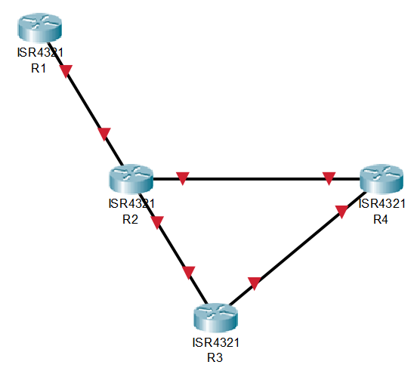



**Switchrouter2(config-router)#do show ip route**

… output omitted…

C 192.168.1.0/24 is directly connected, FastEthernet1/0/1

L 192.168.1.2/32 is directly connected, FastEthernet1/0/1

**O IA 192.168.3.0/24 [110/2] via 192.168.5.2, 00:00:05, FastEthernet1/0/2**

**192.168.5.0/24 is variably subnetted, 2 subnets, 2 masks**

C 192.168.5.0/24 is directly connected, FastEthernet1/0/2

L 192.168.5.1/32 is directly connected, FastEthernet1/0/2

192.168.51.0/32 is subnetted, 1 subnets

**O IA 192.168.51.1 [110/2] via 192.168.5.2, 00:00:05, FastEthernet1/0/2**

* Note: O IA means OSPF Interarea. Notice the **[110/2]**. 110 is OSPF’s default AD.

Before changing the Administrative Distance of EIGRP Exterior route, OSPF AD of 110 is more trust worthy than EIGRP Exterior’s AD 170. So, traffic from R2 to R3 goes through R2 => R4 => R3.

After changing the Administrative Distance of EIGRP Exterior route, EIGRP External routes preempt OSPF. Thus, traffic from R2 to R3 will go directly from R2 => R3 through EIGRP route, which results in more efficient traffic flow.





**Switchrouter2(config-router)#do show ip route**

… output omitted…

**D EX 192.168.3.0/24**

**[105/10474496] via 192.168.2.2, 00:00:10, FastEthernet1/0/3**

**192.168.5.0/24 is variably subnetted, 2 subnets, 2 masks**

C 192.168.5.0/24 is directly connected, FastEthernet1/0/2

L 192.168.5.1/32 is directly connected, FastEthernet1/0/2

192.168.51.0/32 is subnetted, 1 subnets

**D EX 192.168.51.1**

**[105/10474496] via 192.168.2.2, 00:00:10, FastEthernet1/0/3**

* Note: D EX is EIGRP External routes. Notice the **[105/10474496]**. 105 is new AD that we set for EIGRP external routes. The previous 2, and now 10474496 are metrics used in OSPF and EIGRP best route calculation.

### show ip routes:

**R1#show ip route**

192.168.1.0/24 is variably subnetted, 2 subnets, 2 masks

C 192.168.1.0/24 is directly connected, GigabitEthernet0/0

L 192.168.1.1/32 is directly connected, GigabitEthernet0/0

D 192.168.2.0/24 [90/30720] via 192.168.1.2, 00:37:59, GigabitEthernet0/0

D EX 192.168.3.0/24

[170/10477056] via 192.168.1.2, 00:37:58, GigabitEthernet0/0

D EX 192.168.5.0/24

[170/10474496] via 192.168.1.2, 00:37:59, GigabitEthernet0/0

192.168.51.0/32 is subnetted, 1 subnets

D EX 192.168.51.1

[170/10477056] via 192.168.1.2, 00:37:58, GigabitEthernet0/0

**R3#show ip route**

D 192.168.1.0/24 [90/30720] via 192.168.2.1, 00:38:38, GigabitEthernet0/0

192.168.2.0/24 is variably subnetted, 2 subnets, 2 masks

C 192.168.2.0/24 is directly connected, GigabitEthernet0/0

L 192.168.2.2/32 is directly connected, GigabitEthernet0/0

192.168.3.0/24 is variably subnetted, 2 subnets, 2 masks

C 192.168.3.0/24 is directly connected, GigabitEthernet0/1

L 192.168.3.1/32 is directly connected, GigabitEthernet0/1

O IA 192.168.5.0/24 [110/2] via 192.168.3.2, 00:58:49, GigabitEthernet0/1

192.168.51.0/32 is subnetted, 1 subnets

O 192.168.51.1 [110/2] via 192.168.3.2, 01:18:14, GigabitEthernet0/1

**R4#show ip route**

O E2 192.168.1.0/24 [110/1] via 192.168.5.1, 00:52:30, GigabitEthernet0/1

O E2 192.168.2.0/24 [110/1] via 192.168.5.1, 00:52:30, GigabitEthernet0/1

192.168.3.0/24 is variably subnetted, 2 subnets, 2 masks

C 192.168.3.0/24 is directly connected, GigabitEthernet0/0

L 192.168.3.2/32 is directly connected, GigabitEthernet0/0

192.168.5.0/24 is variably subnetted, 2 subnets, 2 masks

C 192.168.5.0/24 is directly connected, GigabitEthernet0/1

L 192.168.5.2/32 is directly connected, GigabitEthernet0/1

192.168.51.0/32 is subnetted, 1 subnets

C 192.168.51.1 is directly connected, Loopback0

## Problems encountered

**Wrong/Confusing Information Online:**

On the Internet, some sources messed up the orders of K1, K2… K5 values. For example, on some source, delay is claimed to be K3 while load is K2. That causes some confusion. But after reading the authoritative material from Cisco themselves, there is no more confusion.

## Summary

I’ve encountered the redistribution between EIGRP and OSPF before (in previous lab: Capturing Stubby OSPF Packets). This lab is mostly a review for my CCNP Certification Test a week ago, which I happily passed.

From this lab, I learnt, in depth, about the mechanism for OSPF’s and EIGRP’s best route calculations (such as what K1, K2… K5 each means and how are they used in the EIGRP algorithm). In addition, I learnt about how different routing protocols translate between each other and together select the best route. And my favorite part of the lab is to manually modify the Administrative Distance of different routing protocol so that we can get a more efficient data flow.